|  |  |  |  |  |  |
| --- | --- | --- | --- | --- | --- |
| Date | 30-Nov-22 | | | Tester Name | Mayuri Patel |
| Environment | Penfax - Test | | | Login used |  |
| Operating System | Select OS | Version: | Update: | | |
| Software Used | Select Software | Version: | Update: | | |
| Select Software | Version: | Update: | | |
| Release version | 22.4.1 | | | | |
| Title |  | | | | |
| Test Type | Regression | | | | |
| Test Scenario | Change Banking information | | | | |
|  |  | | | | |
| Expected Results |  | | | | |
| Pass/Fail | Pass | | | JIRA# | N/A |

Describe your steps with screenshots:

Search a member to change the bank information

Open that member Profile

Go to Payment Instruction under Person Profile

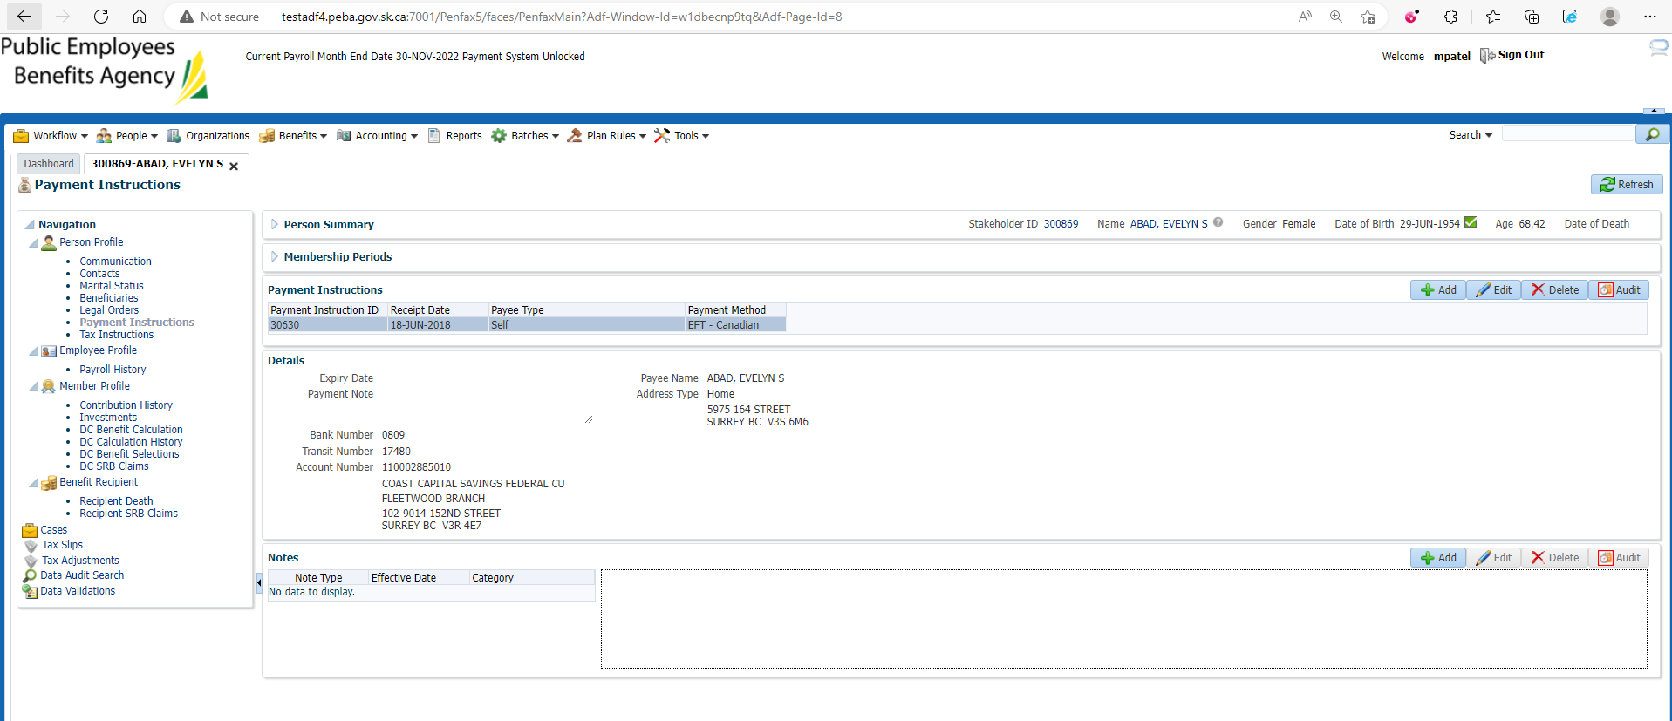

Add Payment Instruction

Enter mandatory details and save

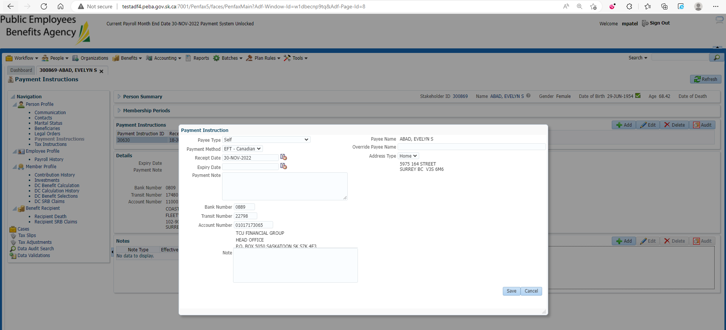

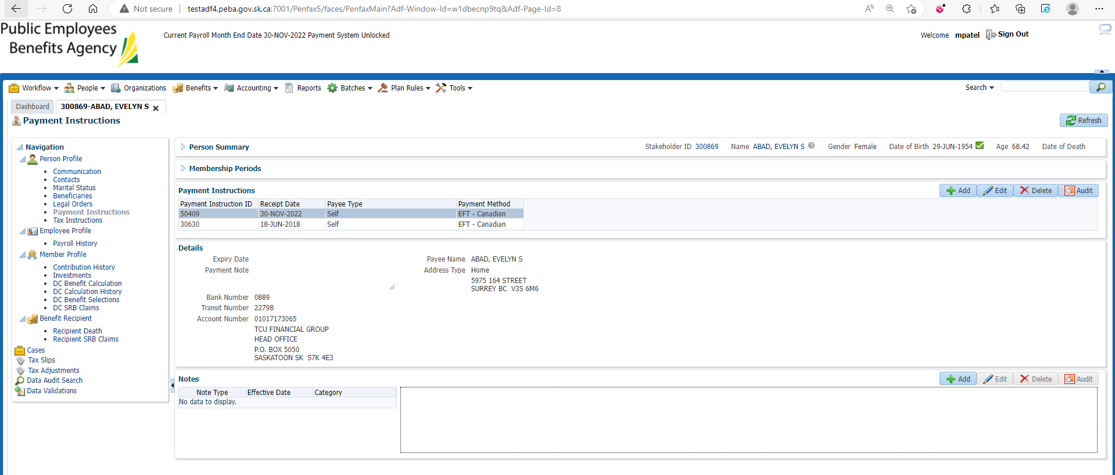

Edit the old Payment Instruction

Enter Expiry Date and Save

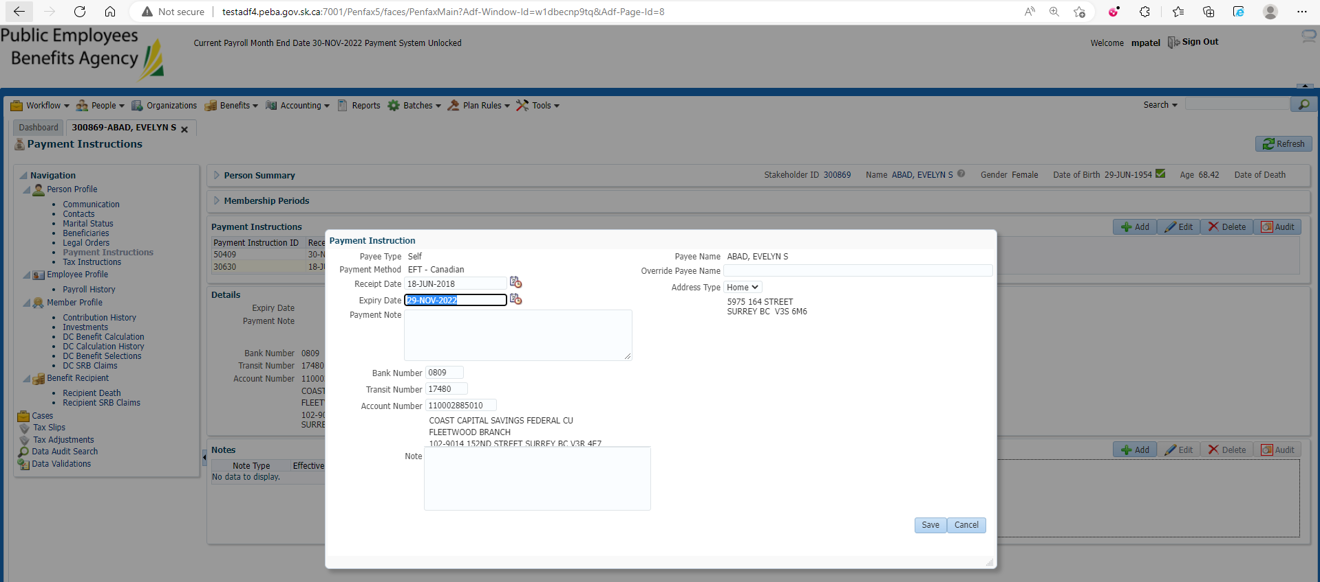

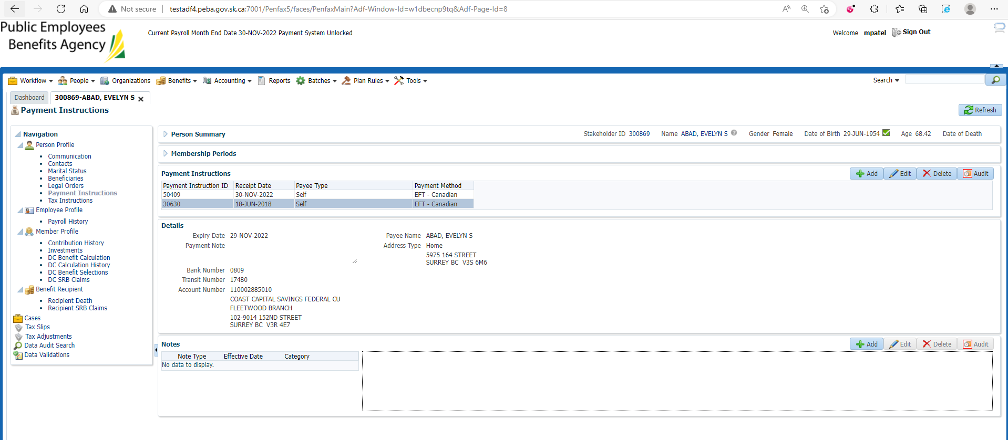

Go to Benefit Recipient

Under Income benefit Tab

Add newly created Payment instruction

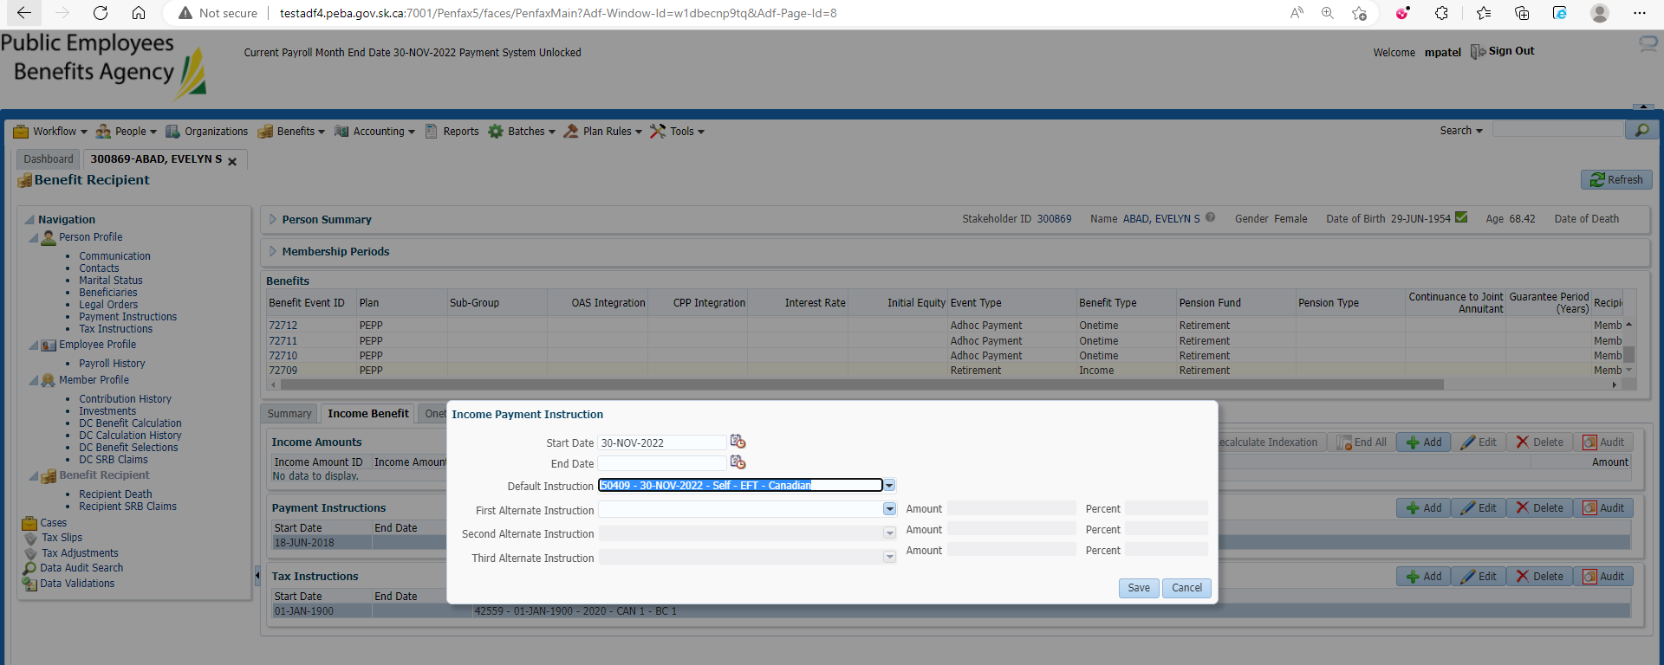

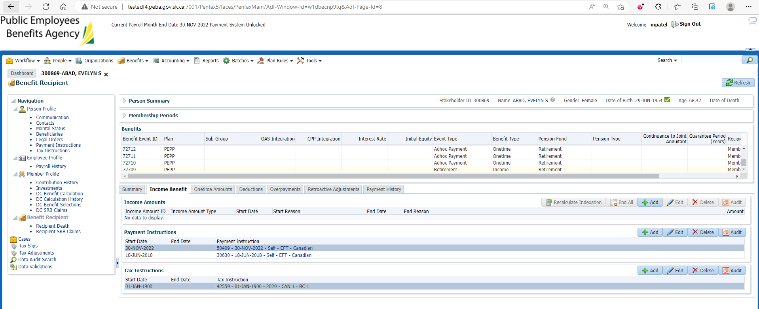

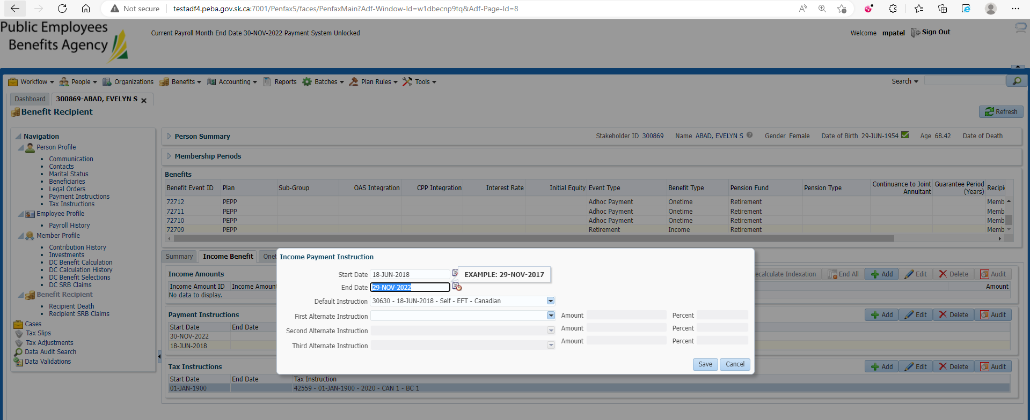

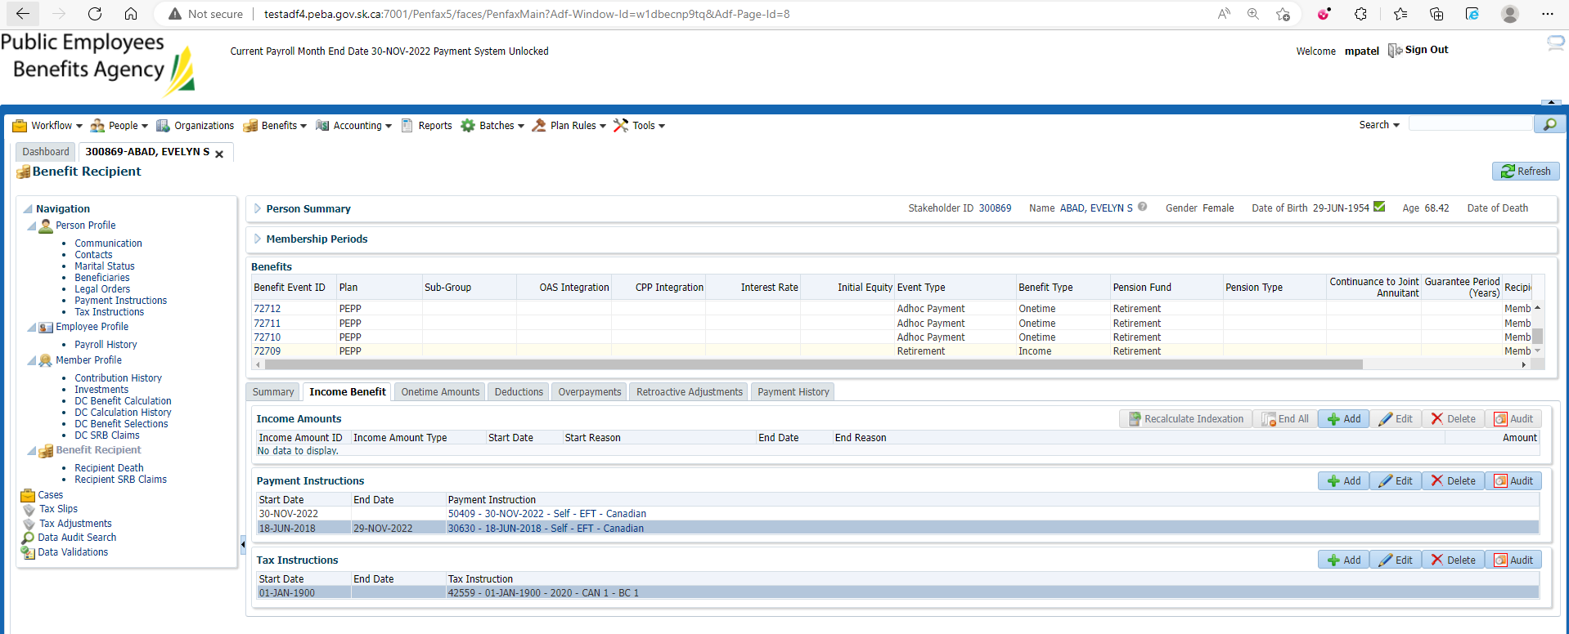

Enter End date for old payment Instruction and Edit old Payment Instruction

(if any)